Statement of Modification

Attached dual occupancy.

209 Bexley Road, Kingsgrove

This statement has been prepared to support a Section 4.55 (1A) - (previous section 96)

Issue 1a

6 July 2022

Kevin Cheong

Fiona Cheong Scott

Owners, 209 Bexley Road

**Introduction**

Reference is made to the Development Consent No. DA-463/2017 and RE-12/2018 issued by Canterbury Bankstown Council, dated 11 July 2018, as well as a subsequent modification determined 25 June 2020.

The consent involved the demolition of existing structures and construction of an attached dual occupancy, and Torrens title subdivision to the subject property known as Lot X DP 391687, No. 209 Bexley Road, Kingsgrove.

**The Site**

The site is located on the western side of Bexley Road, Kingsgrove NSW. The site is rectangular in shape with a front width of 17.6m (approx.) and a total site area of 777m².

Previously existing on site was a single storey residential dwelling of brick construction. At present, construction of the approved two-storey duplex is nearly completed in its exterior aspects.

The subject site is characterized by a mix of residential type developments including single, two storey dwellings, dual occupancies and multi-dwelling buildings.

Adjoining the site to the northern boundary, respectively, is No. 207 Bexley Road, which consists of a single residential dwelling of brick construction. Adjoining the site to the southern side is No. 211 Bexley Road, which consists of a single dwelling house of brick/render construction.

**Development Application History**

An application had been made proposing the demolition of existing structures and construction of an attached dual occupancy and Torrens title subdivision. Approval was granted on 11 July 2018 under a Section 8.2 Review (application RE-12/2018). Modifications to the consent were approved on 25 June 2020.

*Arial View – Subject Site*

**Proposed Modification**

This application for modification is made pursuant to Section 4.55 (1A) of the EPA Act 1979, to modify Consent RE-12/2018 by the following modification:

Removal of bottlebrush tree from council nature strip, and replacement with similar tree elsewhere in nature strip, as the present growth and location will obstruct the entry of vehicles into and out of the approved driveway off of Bexley Road. The tree also restricts visibility when exiting the approved driveway area onto Bexley Road.

*The above pink marks on the tree and on the ground show the corresponding edge of the approved driveway. This illustrates how the primary trunk on the left is an obstruction to driving unimpeded into the approved driveway. It is also a visual obstruction for drivers pulling out into Bexley Road from the approved driveway.*

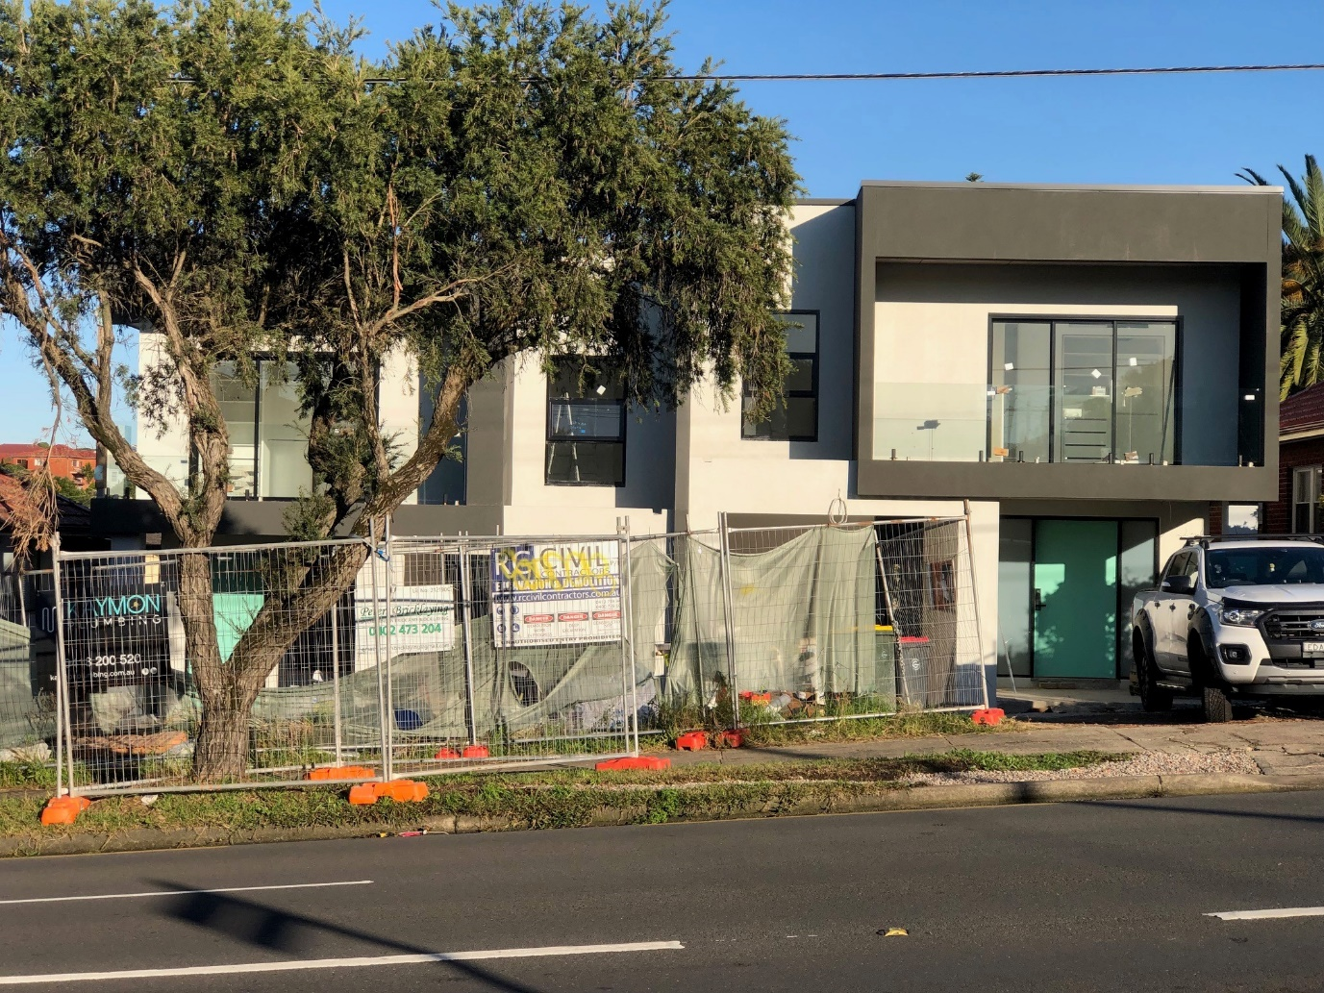

*The above photo has been marked in red to show the extent of the new driveway to be constructed. The circle shows the portion of the existing tree that will partially obstruct the way of vehicles entering the driveway.*

It is noted that the neighbour at 211 Bexley Road received consent to remove the two bottlebrush trees in their section of nature strip as they were obstructing two separate proposed driveways. The consent notice stipulated that replanted trees must be at least 2.5m from new driveway, and the replacement species are to be either Water Gum or Blueberry Ash.

We’d plan to replace the tree along similar guidelines.

**EPA Act 1979 – Section 4.55 Modification of consents—generally (1A)**

Clause 1A of Section 4.55 of the Act states that:

“In determining an application for modification of a consent under this section, the consent authority must take into consideration such of the matters referred to in section 4.15 (1) as are of relevance to the development the subject of the application.”

This section of the Statement of Modifications considers the amended development assessed against the relevant provisions identified in section 4.15 (1) of the Act.

1. s4.55 of the Act sets out the requirement for a modified development approval to be ‘substantially the same’ as the original development.

2. s4.55 of the Act assumes there will be circumstance which arise in the course of carrying out a development that would provide cause to change an approved development. The decision of North Sydney Council v Michael Standley & Associates Pty Ltd, (1997 LGERA 433, 12 May 1998, Mason P) identified as follows:

“Parliament has therefore made it plain that a consent is not set in concrete – it has chosen to facilitate the modifications of consents, conscious that such modifications may involve beneficial cost savings and / or improvements to amenity.”

3. Clause 1A of s4.55 of the Act outlines that a consent authority may modify the development consent if:

(a) *it is satisfied that the proposed modification is of minimal environmental impact, and*

*(b) it is satisfied that the development to which the consent as modified relates is substantially the same development as the development for which the consent was originally granted and before that consent as originally granted was modified (if at all), and*

*(c) it has notified the application in accordance with:*

*(i) the regulations, if the regulations so require, or*

*(ii) a development control plan, if the consent authority is a council that has made a development control plan that requires the notification or advertising of applications for modification of a development consent, and*

***EPA 1979 Section 4.55(1A)***

Despite the proposed modifications, the development will:

a) Not result in any additional environmental impacts and keeping within the development controls and standards contained within Canterbury Development Control Plans.

b) Provide the same dwellings and maintain compliance with Canterbury DCP and LEP i.e floor space ratio, heights, subdivision area, private open space, landscaping, etc.

In that the proposal does not seek to change the nature or any essential elements and use of the original we are of the opinion that the proposed modification is substantially the same development and therefore the Council may proceed to merit assessment so as to satisfy s4.55(1A) of the Act.

**Development Control Plan**

It is evident that the proposed modifications pursuant to s4.55 (1A) remains consistent with the aims and objectives of the Canterbury DCP as the proposed changes will not alter or change any setbacks to the frontage, streetscape appearance and any potential environmental impacts from that which are outlined in the original development.

**Local Environmental Plan**

The proposed modifications will remain consistent with the general aims and objectives of the Canterbury LEP being that of a residential development providing for the housing needs of the community within a low density residential environment.

**Conclusion**

The proposed modifications will not result in any additional environmental impacts and are keeping within the development controls and standards that of Canterbury Bankstown Council.

The modifications will provide the same dwellings and maintain compliance with Canterbury DCP and LEP i.e floor space ratio, heights, subdivision area, private open space, landscaping, as original approved.

Based on the above assessment it is therefore suggested that Canterbury Bankstown Council takes into consideration the above report and grants consent to our proposal in the form and manner submitted.

Regards,

Kevin Cheong

Fiona Cheong Scott

Owners, 209 Bexley Road, Kingsgrove